5.75: a) The product 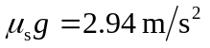is greater than the magnitude of the acceleration of the truck, so static friction can supply sufficient force to keep the case stationary relative to the truck; the crate accelerates north at 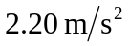, due to the friction force of 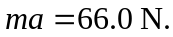 b) In this situation, the static friction force is insufficient to maintain the case at rest relative to the truck, and so the friction force is the kinetic friction force, 